« LES ROLANDINS »
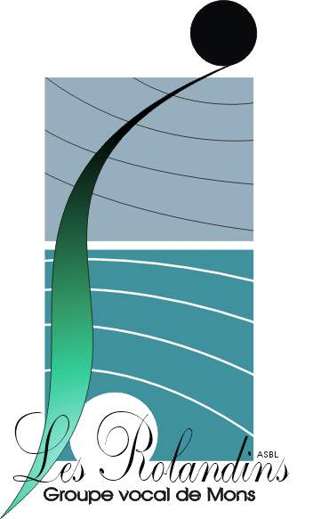

Mons vocal group

In 1968, as they were about to perform for the first time at the Royal Theatre of MONS, a still nameless newborn vocal group founded by a few lovers of the Renaissance music was introduced as « LES ROLANDINS », subtly referring to Roland de Lassus, one of the famous musicians of the Renaissance, born in 1530 in MONS.
Since then « Les Rolandins » have been performing hundreds of times in Mons and elsewhere in Belgium, Germany, Spain, the United States, the Cszech republic, Slovenia and Portugal.
As the most representative choir of MONS, « Les Rolandins » are always keen on passing on their passion for music and vocal music, whatever audiences.
Thanks to relentless work and quest for quality, nuances ad originality, the vocal group has often been rewarded with first class honours at the Hainaut Choral Art Festivals. They were several times on TV and radio shows (RTVE-Spain, RTBF, RTL-TVI, Télé MB, ….) and they are unanimously recognized and supported by the « Tournées Art et Vie » » of the Belgian French-speaking community .
Whereas their repertoire was mainly devoted to works by Roland de Lassus and other Renaissance composers, it was gradually extended to the Romantic period, popular and even light songs. The latest repertoires range from rarely sung sacred as well profane works by Russian masters (Tchaikovsky, Rachmaninov…) to poets and writers from Orphée to Brassens and Ferré.
As an official ambassador of MONS 2015, European capital of culture, « Les Rolandins » take part in every cultural event of the Town of the Doudou : music festivals, singing Roland de Lassus songs in traditional costume at the Car D’Or (the golden ceremonial carriage ) procession, or at the Descent of the relicshrine of Saint Waltrude during the yearly Ducasse.
Yves Wuyts, founder of group X in 1968, was its all-time director and conductor. In order to transmit this heritage, he appointed in January 2018 a new leader, Denis Francotte, who engaged himself to take the group towards its centenary.
« Les Rolandins » have been a member of Fédération chorale Wallonie-Bruxelles « A CŒUR JOIE » since it was created, and « La Fédération musicale du Hainaut ».

Information : www.rolandins.be
Groupe vocal de MONS « LES ROLANDINS »
c/o Pascal GILQUIN, President
Chemin des Préelles, 28A/12
B – 7000 MONS – Belgium
Tél. : +32-(0)65.31.70.01 - +32(0)496.51.39.85
president@rolandins.be

